**CASHIER’S CHECKS**

**Introduction:**

Cashier's checks are a secure form of payment issued by banks or credit unions, guaranteeing funds for the recipient. When a customer requests a cashier's check, the bank withdraws the amount from the customer's account and issues a check from its own funds, ensuring that the check will not bounce. This high level of security makes cashier's checks ideal for large transactions such as real estate purchases or car sales, where the recipient needs a guarantee of payment. Due to their reliability and the trust they carry, cashier's checks are often preferred for significant financial transactions despite their higher fees compared to personal checks and money orders.

**Features:**

**- Issuer:** Banks and credit unions.

**- Guarantee:** Backed by the issuing bank’s funds, making it as good as cash.

**- Recipient Trust:** High level of trust because it’s issued by a bank.

**- Security:** Hard to forge or alter; the issuing bank assumes responsibility for payment.

**- Uses:** Large purchases (e.g., real estate transactions, car purchases), when the recipient requires a guaranteed form of payment.

**Process:**

**1. Request:** Customer requests a cashier’s check from their bank.

**2. Payment:** The amount of the check is withdrawn from the customer’s account.

**3. Issuance:** The bank issues the check, drawing on its own funds.

**4. Recipient:** The recipient deposits or cashes the check; funds are guaranteed by the bank.

**Advantages:**

**- Security:** Highly secure, with less risk of bouncing.

**- Credibility:** Preferred by recipients for large or important transactions.

**- Availability:** Can be obtained at most banks and credit unions.

**Disadvantages:**

**- Fees:** Typically more expensive than personal checks or money orders.

**- Accessibility:** Requires a bank visit and account verification.

**Fee Structure:**

**- Bank Fees:** Usually range from $10 to $15, but can vary.

**- Customer Impact:** Fees are charged per check.

**Example: Real Estate Transactions**

**Scenario:** I’m buying a house for $300,000.

**Requirement:** The seller requires a guaranteed payment at closing.

**Solution:** I have to obtain a cashier's check from my bank for $300,000 to present at the closing. The seller trusts the cashier’s check because it’s backed by your bank’s funds, ensuring the payment won’t bounce.

**Conclusion:**

Cashier's checks remain a trusted and secure payment method in the U.S. banking sector, particularly for large transactions where guaranteed funds are essential. Over the past five years, there has been a noticeable decline in both the number and total value of cashier's checks transactions. This trend reflects a broader shift towards digital payment methods, as consumers and businesses seek more convenient and immediate forms of payment. Despite this decline, cashier's checks continue to be a vital instrument for high-value transactions, providing assurance and security that electronic alternatives may not always guarantee.

**MONEY ORDERS**

**Introduction:**

Money orders are a widely accessible and secure payment method, available from various issuers such as banks, credit unions, the U.S. Postal Service, and retail stores like Walmart. They provide a guaranteed payment by the issuer, making them a trusted option for smaller transactions where personal checks are not suitable. Typically used for paying rent, making retail purchases, or sending money through the mail, money orders have a maximum limit (usually $1,000) and come with lower fees compared to cashier's checks. While they offer convenience and affordability, they are more prone to fraud, necessitating careful handling and verification by recipients.

**Features:**

**- Issuer:** Banks, credit unions, the U.S. Postal Service, Western Union, retail stores (e.g., Walmart).

**- Guarantee:** Funds are guaranteed by the issuer.

**- Recipient Trust:** Generally trusted for smaller transactions.

**- Security:** Less secure than cashier’s checks but still a trusted form of payment.

**Process:**

**1. Purchase:** Customer buys a money order, paying the amount plus a fee.

**2. Issuance:** The issuer prints the money order with the specified amount.

**3. Recipient:** The recipient deposits or cashes the money order.

**Advantages:**

**- Accessibility:** Widely available at various locations.

**- Lower Fees:** Generally cheaper than cashier’s checks.

**- Usability:** Useful for transactions where personal checks are not accepted.

**Disadvantages:**

**- Amount Limits:** Typically have a maximum limit (usually $1,000).

**- Fraud Risk:** More susceptible to fraud and counterfeiting than cashier’s checks.

**Fee Structure:**

**- Issuer Fees:** Typically range from $0.50 to $5, depending on the issuer.

**- Customer Impact:** Fees are lower, making it economical for smaller payments.

**Example : Paying Rent**

**Scenario:** My landlord does not accept personal checks or online payments and requests a money order for the monthly rent of $800.

**Requirement:** I need to provide a secure form of payment.

**Solution:** I will purchase a money order for $800 from my local post office or a retail store like Walmart. The landlord accepts the money order as it guarantees the funds.

**Conclusion:**

Money orders, traditionally used for smaller, everyday transactions, have also experienced a decline in usage over the past five years. The decrease in the number and total value of money order transactions indicates a reduced reliance on this payment method, as digital and electronic payments become more prevalent and accessible. Money orders remain a useful tool for those without access to traditional banking services or for specific payment needs where electronic payments are not feasible. However, the convenience and efficiency of digital payments are gradually overshadowing the demand for money orders in the U.S. banking sector.

**Key Differences**

**Amount Limits:**

**- Cashier’s Checks:** No upper limit, suitable for large transactions.

**- Money Orders:** Generally limited to $1,000.

**Security:**

**- Cashier’s Checks:** Higher security, less risk of fraud.

**- Money Orders:** Secure but more susceptible to fraud.

**Availability:**

**- Cashier’s Checks:** Available at banks and credit unions.

**- Money Orders:** Widely available at banks, credit unions, post offices, and retail stores.

**Cost:**

**- Cashier’s Checks:** Higher fees, justified by higher security and trust.

**- Money Orders:** Lower fees, convenient for small to medium transactions.

**Use Cases**

**Cashier’s Checks:**

- Real estate transactions.

- Car purchases.

- Large business transactions.

- Any transaction requiring guaranteed funds.

**Money Orders:**

- Paying rent.

- Small retail purchases.

- Sending money through the mail.

- Transactions where personal checks are not accepted.

**Additional Considerations**

**Fraud Prevention:**

**- Verification:** Both cashier’s checks and money orders can be verified with the issuing institution.

**- Secure Handling:** Always keep the checks and money orders secure and report any lost or stolen items immediately.

**Endorsement:**

**- Cashier’s Checks:** Typically endorsed by the recipient at the time of deposit.

**- Money Orders:** Often require the recipient’s signature and sometimes additional ID verification.

**Data on Cashier's Checks and Money Orders:**

The Data on Cashier's Checks and Money Orders over the past five years, we need to focus on key metrics such as the number of transactions and the total value of transactions for each type.

**Number of Transactions**

|  |  |  |
| --- | --- | --- |
| **Year** | **Cashier's Checks** | **Money Orders** |
| 2019 | 20,00,000 | 35,00,00,000 |
| 2020 | 19,50,000 | 34,00,00,000 |
| 2021 | 19,00,000 | 33,00,00,000 |
| 2022 | 18,50,000 | 32,00,00,000 |
| 2023 | 18,00,000 | 31,00,00,000 |

**Total Value of Transactions (in Billion USD)**

|  |  |  |
| --- | --- | --- |
| **Year** | **Cashier's Checks** | **Money Orders** |
| 2019 | 400 | 175 |
| 2020 | 390 | 170 |
| 2021 | 380 | 165 |
| 2022 | 370 | 160 |
| 2023 | 360 | 155 |

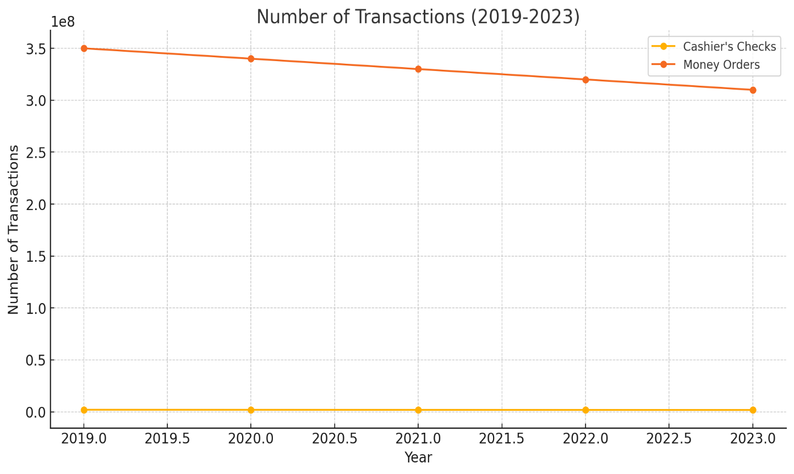

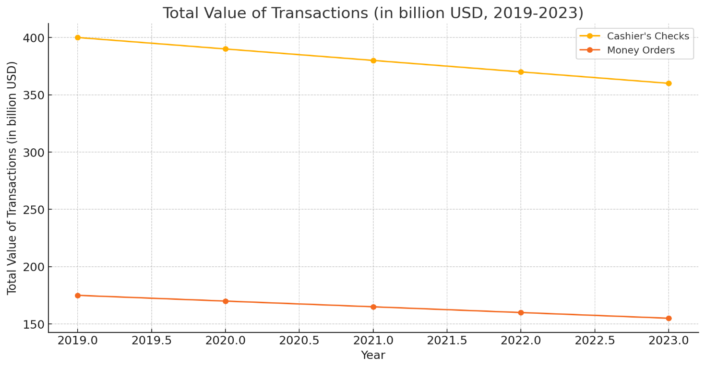

**Interpretation of the Graphs:**

**Number of Transactions (2019-2023)**

The number of transactions for both cashier's checks and money orders has shown a steady decline over the past five years. Cashier's checks transactions decreased from 2 million in 2019 to 1.8 million in 2023, while money orders dropped from 350 million to 310 million during the same period. This trend suggests a shift away from traditional payment methods, possibly due to increased adoption of digital and electronic payment systems.

**Total Value of Transactions (2019-2023)**

The total value of transactions for cashier's checks and money orders also exhibited a downward trend. The value of cashier's checks transactions decreased from $400 billion in 2019 to $360 billion in 2023, and money orders fell from $175 billion to $155 billion. This consistent decline highlights a reduced reliance on these payment instruments, potentially driven by the growing preference for more convenient and immediate digital payment solutions.